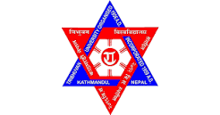

**TRIBHUVAN UNIVERSITY**

**INSTITUTE OF SCIENCE AND TECHNOLOGY**

**A**

**FINAL YEAR PROJECT REPORT**

**ON**

**<“amc chatbot”>**

**Submitted To:**

**Department Of Computer Science and Information Technology Tribhuvan University Kritipur, Kathamandu**

***In partial fulfilment of the requirement of the bachelor’s degree in computer science and information technology***

**Under the supervisionof**

**<“Teacher’s Name”>**

**Ambikeshwari Campus**

**Ghorahi, Dang**

**Submitted by:**

1. N14(TU ROLL.NO)
2. Z07(TU ROLL.NO)

**DATE…….**